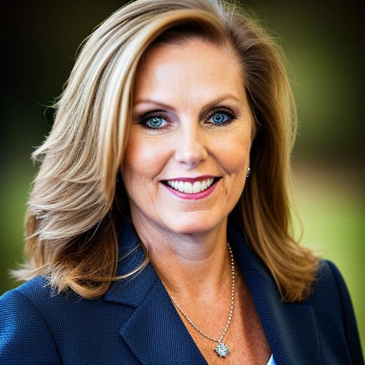

***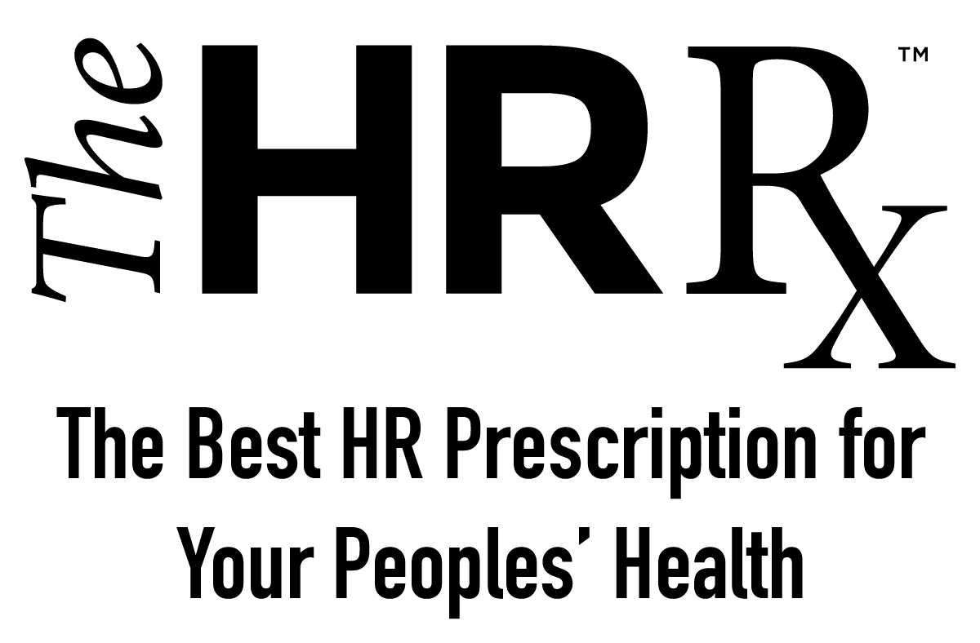*"PREVENTING PEOPLE PROBLEMS"**

***Gain Strategic Insights to Mitigate Legal Risk!***

***With Helena Ferrari, GPHR,PHR - Strategic Business Partner***

***Are you prepared to embrace advanced approaches to drive profitability through people-driven strategies?*** Invite Helena to share revealing data and proven approaches to build and maintain **increased financial efficiency, people productivity, and talent engagement that directly contributes to top and bottom-line results.**

As a global CHRO and strategic Executive Team member, I work with CEOs, C-suite and the Board of private/PE companies on governance, scaling global growth, risk management, cross-border M&As, IPOs, regulatory compliance, audits, succession planning, compensation, and workforce strategy. I provide valuable actionable solutions drawing from a growth-focused mindset and cultural nuance gained via 25+ years leading businesses to scale across the US, UK, Australia, Europe, LatAm, and APAC regions – ensuring shareholder value and responsible corporate cultures. I help businesses navigate crisis including multi-CEO/Executive Team transitions, financial turnarounds, class action claims, dissolving businesses, and with delicate CEO/C-level matters.

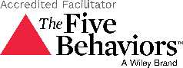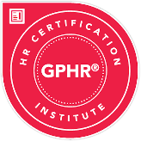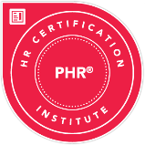

**Strategic People Audits**

Boost business impact by leveraging workforce data analytics to pinpoint areas to increase operational efficiencies in the areas of talent attraction, retention, and engagement.

**Frequent Results:**

* Expanded efficiency, cost saving, and improved resource allocation.
* Lowered turnover and increased offer to hire metrics.
* Strengthened company brand, eNPS, culture and retention that led to higher confidence with stakeholders and marketplace.



***Operational Results***

1. *Reduced Insurance Renewals by 20%.*
2. *Decreased Employee Relations by 60%*
3. *Lowered Turnover Costs by 45%.*
4. *Increased Talent Attraction by 30%*
5. *Increased Retention Scores by 25%*
6. *Increased stakeholder, customer, partners trust in corporate governance. Priceless!*

**People Leader Development and Coaching**

Enhance Leadership Effectiveness through development and coaching programs to foster a new mindset, shift behaviors, and rewrite what it means to work together increasing competencies, skills, and leader success at all levels.

**Frequent Results:**

* Improved emotional intelligence, communication, and decision-making.
* Enhanced employee engagement, motivation, and retention.
* Advanced team performance, collaboration, problem solving.

**Mitigate Employer Legal Risk**

Proactive risk assessments and preventative lawful services to avoid legal issues and financial liabilities through data analytics, due diligence audits, process and policy alignment and lawful workshops preventing top and bottom-line costly mistakes,

**Frequent Results:**

* Minimized financial cost and reduced insurance premium renewals.
* Increased stakeholder, customer, partners trust in corporate governance.
* Decreased employee relations issues that led to litigation, fines, and penalties.

***With Helena Ferrari, GPHR, PHR – Maximizing People, Productivity, and Profit***

***STRATEGIC WORKSHOPS AND SPEAKING ENGAGEMENTS***

|  |  |  |
| --- | --- | --- |
| Scales of justice with solid fill  **Mitigate Employer Risk**  Discover vulnerabilities through risk assessments and strategies to lower insurance premiums and employee relations issues while preventing substantial related lawsuits.  ***Highly collaborative session with practical real-world scenarios of successful risk avoidance and cost savings.*** | Users with solid fill  **Accelerate Employer Brand**  Learn the power of building strategies aligned with employer branding for talent attraction, retention, and engagement and measurement methods to increase stakeholder and customer value.  ***Drawing inspiration from success stories of 'Employers of Choice' branding showcasing ROI impact on the bottom-line.*** | Brainstorm with solid fill  **Enhance Leaders Performance**  Develop Leadership effectiveness to align actions, behaviors, and communications with culture and business goals to increase attraction, retention, and engagement to bottom line results.  ***Interactive application concepts to enhance skills, competencies, and leader effectiveness driving profitability results.*** |
| *Helena’s ability to convey the significance of HR metrics within the broader context of organizational success was top notched.*  *What sets her apart is her capacity to convey HR metrics in business terms but also to provide real-world examples of how these metrics drive tangible results.* *Throughout her presentation, she seamlessly integrated key performance indicators, workforce analytics, and financial outcomes, leaving the audience with a clear understanding of how HR decisions impact the bottom line. Helena left the audience inspired and motivated to implement data-driven HR strategies within their organizations.*  *- Thoai Ha, CHRO* | *“I really enjoyed Helena Ferrari’s presentation at the ENP Summit and found the discussion of her experiences supporting businesses over the years, and particularly the importance of being a people-driven company, insightful, timely and on-point, especially for businesses who are growing. Her insights into the significance of leadership branding in connection with attracting, retaining, and engaging top talent was also fantastic!”*    *- John Wicker, Labor, and Employment Attorney Stradling* | *Helena is an impactful consultant and speaker. She understands that the people in your organization are your greatest asset. Helena is committed to helping companies attract, retain, and engage your people as a competitive advantage in your market. Her global expertise as a business consultant and human resources specialist will deliver actionable solutions for you as a leader, for your teams, and for your organization.*  *- Holly Johnson, Chief Engagement Officer Blue Water Leadership* |

***Scan to schedule your consultation today!***

